

Rusty Degarmo, Mitchell Kwon, Aurora Lopez, Lucas Ramsey and Parrish Ward

Bellevue University

CSD 310: Database Development and Use

Project Milestone: Outland Adventures

Milestone 3

# **Milestone Three**

### Report One: Equipment Sales

**Question**

Do enough customers buy equipment to keep equipment sales?

**Description**

Query the Customer table to count how many customers buy and how many rent their equipment.

**Python Script**

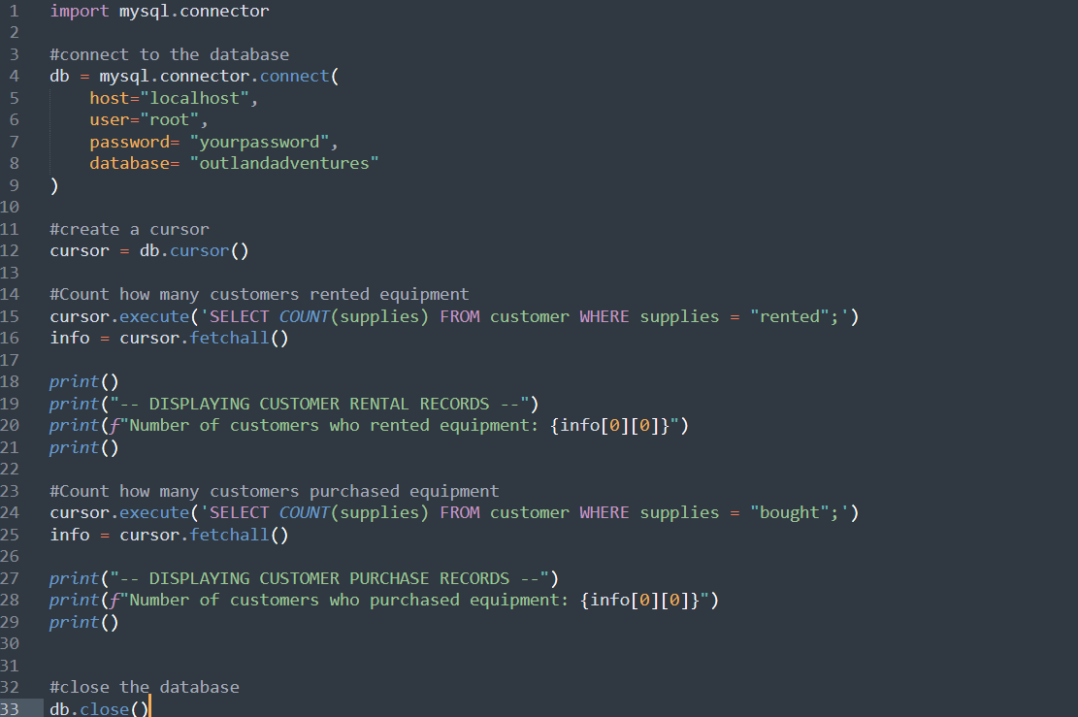

**Output Screenshot**

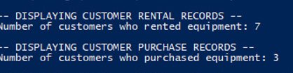

**Interpreting Results**

The data demonstrates that there are seven customers who rented and three that made purchases. The business owners could interpret the data as that it is not profitable to provide the equipment up for purchase; however, there is still a 30% gain.

### Report Two: Number of Treks per Location

**Question**

So far, they have conducted treks in Africa, Asia, and Southern Europe. Is there anyone of those locations that has a downward trend in bookings?

**Description**

Query the Trip table to count how many treks there have been to each location.

**Python Script**

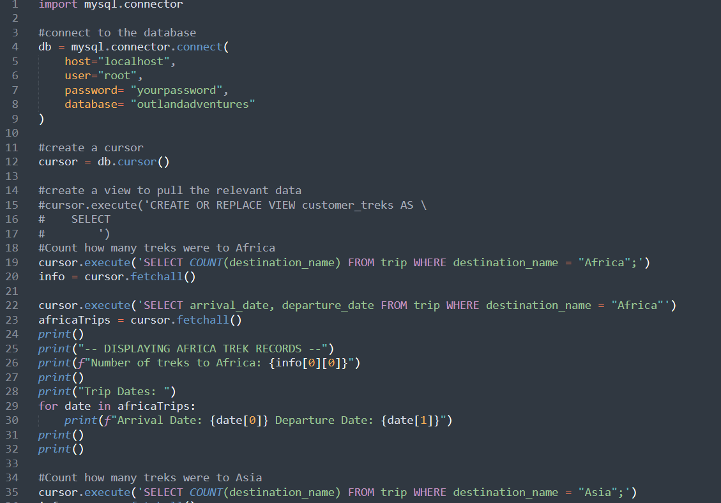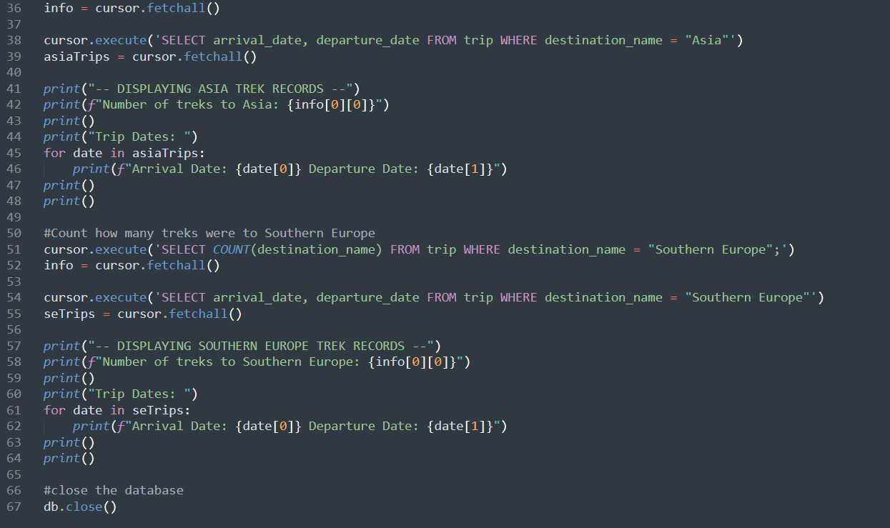

**Output Screenshot**

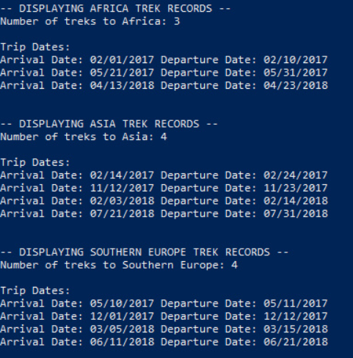

**Interpreting Results:**

The data demonstrates that there have been 4 trips to Southern Europe, four trips to Asia and three trips to Africa. The business owners could interpret the data as the trips being evenly visited, even though Africa has one less trip.

### Report Three: Aged Equipment

**Question**

They are a little concerned about the age of some of the inventory. Are there inventory items that are over five years old?

**Description**

Query the Supply table to count how much of the inventory is more than five (5) years old.

**Python Scripts**

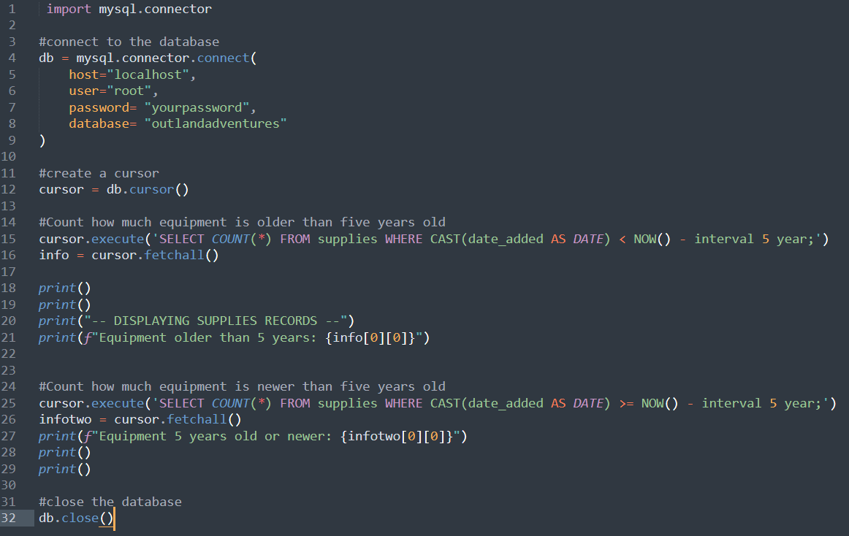

**Output Screenshot**

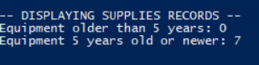

**Interpreting Results**

Based on the report, there is no equipment that is dated older than five years old.